This document is a demo of the running project,

**Main Webpage:**

It shows two buttons:

**View Chart:** View one-month data of three stocks on the same chart from period 01-January-2018 to 31-January-2018.

**View Average Data:** View the average data for three days of each stock separately from period 29-January-2018 to 31-January-2018.

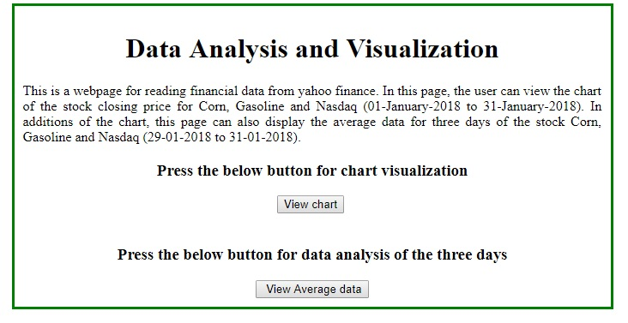

When user clicks on the button **“Press the below button for chart visualization**”, the following chart should be display to the user,

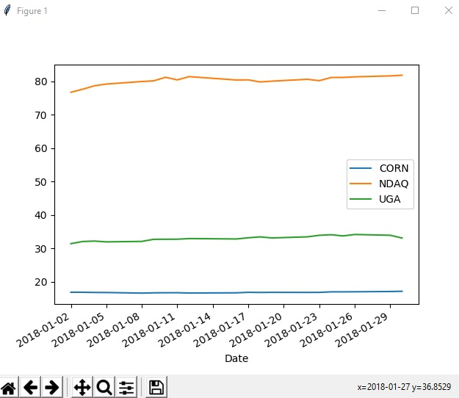

When user clicks on the button **“Press the below button for data analysis of the three days”**, the following three message boxes should display to the user,

* Keep in mind, the first messagebox “CORN” should be shown, when user clicks on button “OK”, the next messagebox “Gasoline” should be shown to the user, when user clicks on button “OK”, the next messagebox “Nasdaq” should be shown to the user.

**Corn message box:**

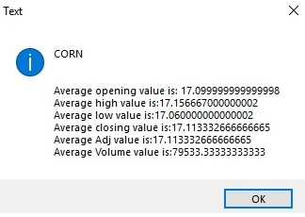

**Gasoline message box:**

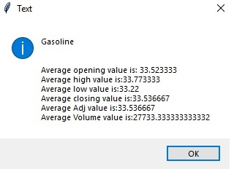

**Nasdaq message box:**

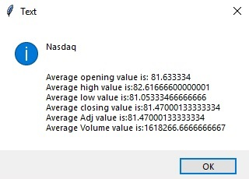

**Important Note:** User should first close the window for the chart to view average data and vice versa.